Start with an inspiring introduction

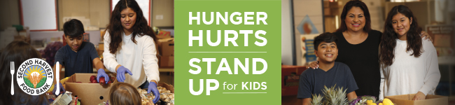

Subject: Local hunger is solvable. You are the solution.

Dear [Name],

I recently learned that 1 in 3 kids in Santa Clara and San Mateo Counties are not getting enough to eat. Astronomical rents in Silicon Valley are keeping many hardworking families from getting ahead and kids are saying they feel like a burden – no child should feel that way.

We have the power to make a difference and connect these kids to the healthy and nutritious food they need to thrive.

Join [organization name] in standing up for these children. Every $1 or 2.4 pounds you donate creates 2 meals. Bring non-perishable food items to [insert barrel location] or donate online here [link to your online progress page that you’ll find in your confirmation email]. Every little bit counts!

What's really cool about Second Harvest Food Bank is that 90% of the food they distribute is highly nutritious and over 50% is fresh produce.

Can we count on you to help us reach our goal of $ [ ] and [ ] pounds?

For the kids,

[Name]

