Send an eye-opening progress update

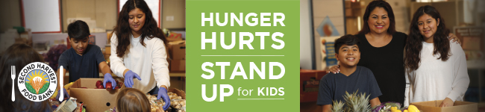

Subject: There is still time! Together we can give kids the food they need to thrive.

Dear [Name],
Thank you to everyone who has donated to our Food and Fund Drive so far. Together, we’ve already raised [number listed on your fundraising page] meals for the kids in our neighborhoods!
But there is only [amount of time left] left and we need to raise $[ ] and [ ] more pounds of food to reach our goal.
Bring non-perishable food items to [insert barrel location] or donate online here [link to your online fundraising page] before [insert drive end date here]. Remember, every $1 will create 2 nutritious meals for kids who are struggling to keep up.
Local kids are counting on us. We can do this!
For the kids,
[Name]

