End with a celebratory thank you
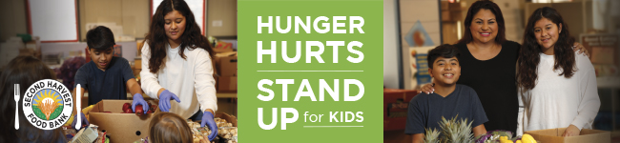
Subject: Thank you
Dear [Name],
We did it! Thanks to your incredible generosity and support, [organization name] created [total number of meals created] meals for local children through our Second Harvest Food Bank Food and Fund Drive.
We joined together to raise $[ ] and [ ] pounds of food. That is something to be proud of!
It feels great to know we have made an impact in the lives of local kids.
Thank you for all your hard work.
Sincerely,
[Name]

