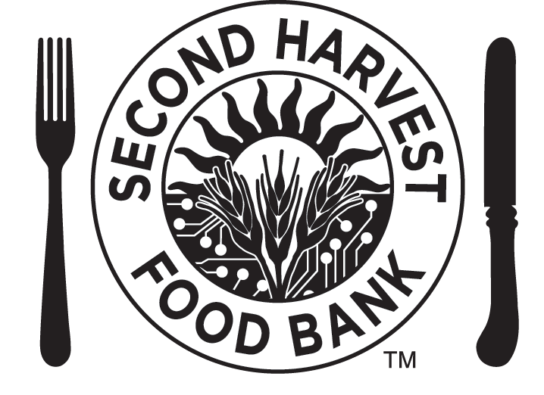

Parent/Guardian Permission Form

FAMILY FOOD SORT
September 22, 2018

Dear Parent or Guardian:

Second Harvest Food Bank of Santa Clara and San Mateo Counties requires permission for anyone under the age of 18 to participate in any volunteer activity. Volunteers under the age of 16 must be accompanied by an adult. Dependent upon the activity and location, Volunteer Family Activities may include youth as young as 8 years of age.

All volunteers will be required to follow the directives of the volunteer supervisors and other staff members. Youth volunteers must have a current Parent/Guardian Permission Form on file at the Second Harvest Food Bank in order to volunteer.

Volunteer Activity: Family Food Sort Day
Saturday, September 22, 2018

Location: Second Harvest Food Bank – Cypress Center
4001 North First Street, San Jose, CA 95134

Time:

I verify that (print youth's name) is currently years of age and

I, (print parent's/guardian's name) give permission for him/ her to

participate in a Second Harvest Food Bank activity at the above location.

This permission slip is valid through September 22nd, 2018.

By my signature below, I do release and indemnify, defend and hold harmless, Second Harvest Food Bank of Santa Clara and San Mateo Counties from and against any and all claims, actions, suits, or proceedings of any kind or nature arising as a result of the actions of my child.

I also release the officers, staff, and Board of Directors of Second Harvest Food Bank of Santa Clara and San Mateo Counties, without limitations, from damages, liabilities, penalties, costs, expenses, legal fees, and claims.

Please print the following information:

Name: Date:

Relationship to Youth:

Signature of Parent or Guardian:
Rev 10/12

