Welcome to Electronic Check-In and Registration!
This is a single application that allows you to Check in and Register new clients on the tablets. within. There is also a Declined Registration tab for those clients who prefer not to share their information. Note: A Household is all the people you share food with regularly.

- Tablet Login code: 2668866

- You will be directed to the Home Page. Select the Icon labeled “Client Check-in”

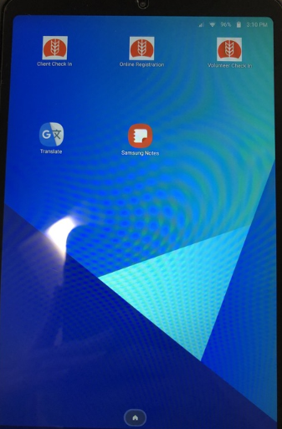

- You will be directed to this screen. The site lead or registration lead will enter the Site Code and Access Code

- You will be directed to this screen. Verify that you are in the correct Distribution Event.
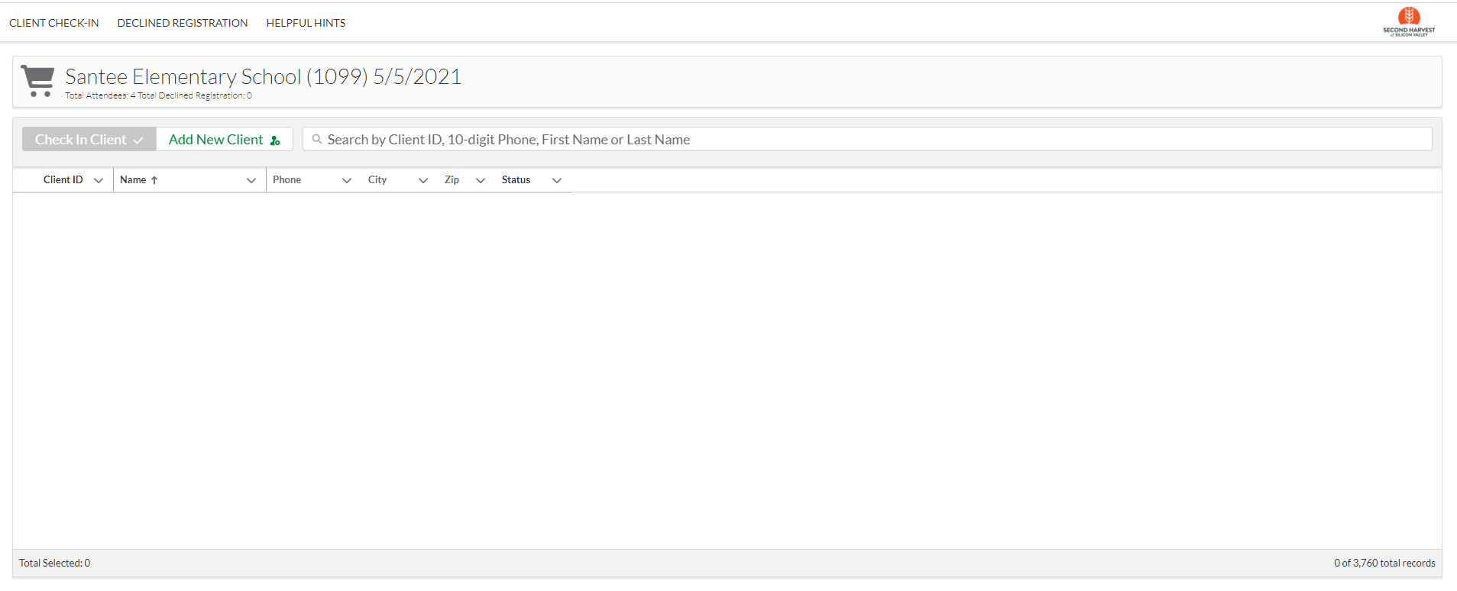

Scenario 1: Client Check-in
Client has gotten Free Groceries from this site before
- Ask the client if they have gotten Free Groceries from this site before. (Do you have your client card?) If yes, then search for the client in the search bar that is under the name of the distribution.

Enter one of the following to search for a client:
- Client ID – Don’t forget the “M” before the numbers
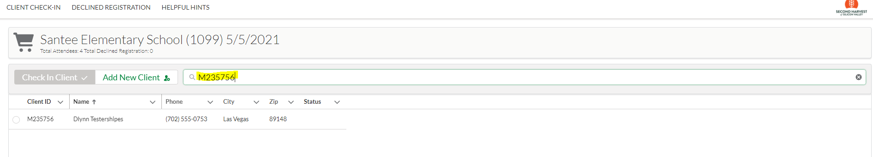

- Phone number (at least four digits)
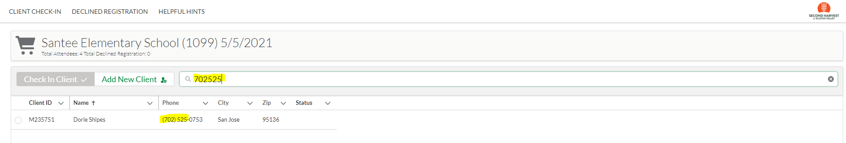

- Name (First OR Last Name is best): You must include at least three characters of the name (use a space at the end of a two-letter first name and a space at the beginning of a two-letter last name)
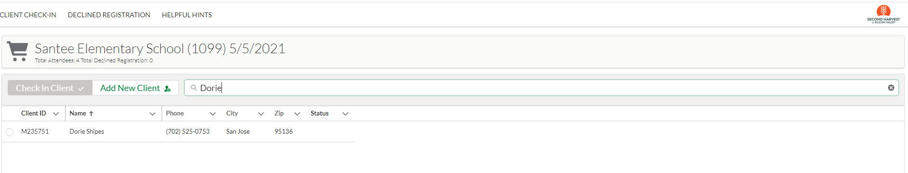

2) You will see a list of clients whose data matches the data you entered
(e.g., if you enter 1234, any client with 1234 in their record will be listed, whether it’s their Client ID or phone number)
- Important Note: Sometimes client names will only be partially entered. For example, Maria del Refugio Velazquez Gomez might be entered in the system as Maria Gomez. Therefore, it is most efficient to first search by their client ID or first name or their phone number instead of searching by their first and last names together.
- Many clients have similar or identical names. Once results are returned, make sure you select the correct client by confirming their name, phone number and/or Client ID (remember, we never need to see their personal ID, such as a Driver’s License).

3) If you find the correct client, select their name by clicking the bubble to the left of the client ID:

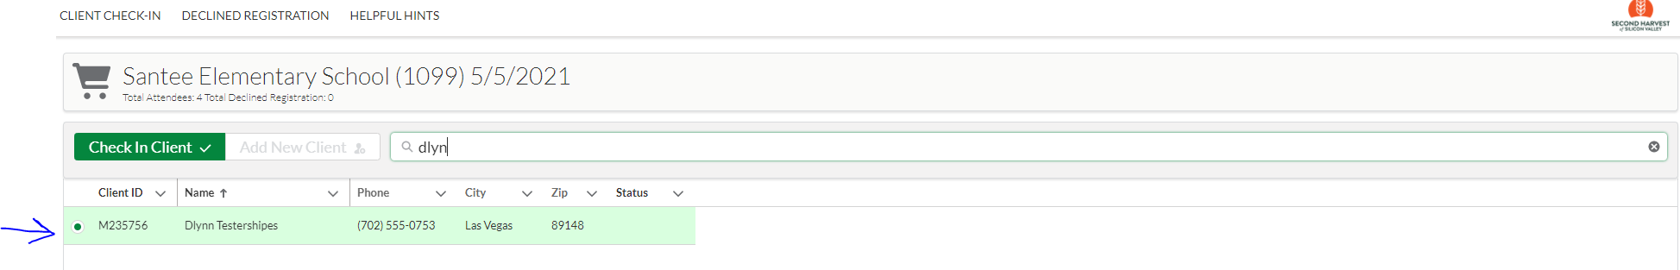

4) Once you have selected the client and your choice is highlighted in green, click on the green Check-in Client ✅ button next to the search bar:

You will be taken to the Confirmation Screen:

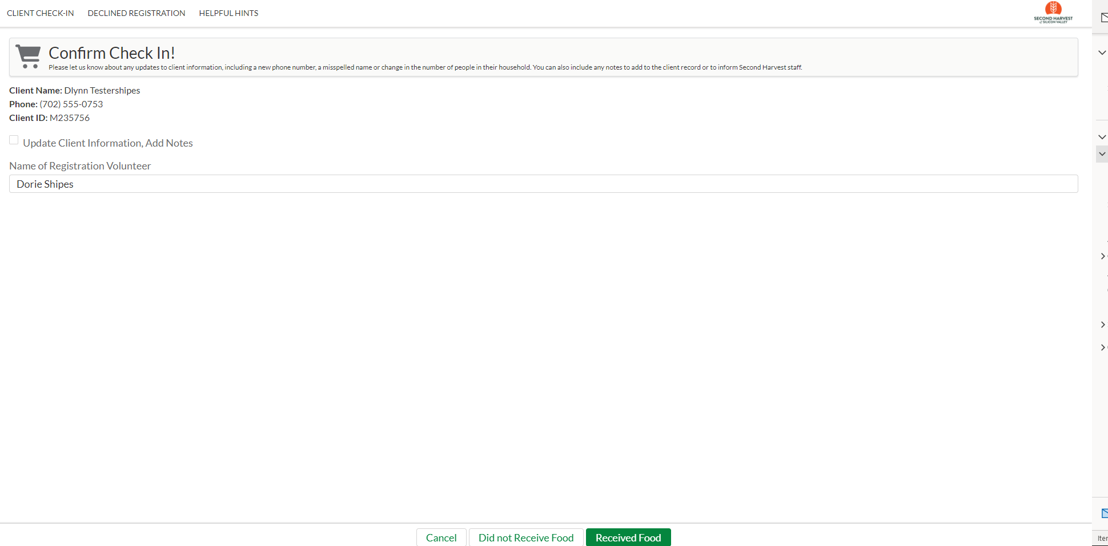
- If a client needs to update their information (such as name or phone number), you can document the changes by clicking on the box next to Update Client Information, Add Notes. A box will display and any changes can be documented. This box can also be used to indicate a client’s Consent to Text.

- The first time you check-in a client, you will need to enter your name into the “Name of Registration Volunteer” box. Please use your first and last name.

- Don’t forget to mark the client as attended! Click on either the green “Received Food” button or the white “Did not Receive Food” button. (Use the Did not Receive Food button if the distribution runs out of food before the client gets to the front of the line).

To Cancel the check-in in process or if you have selected the current client in error, press the white Cancel button at the bottom of the screen. Cancelling will cancel attendance and return you to the original Check-in Screen.

**Please confirm any updates with the client before sending.

- Marking the client as “Received Food” or “Did not Receive Food” will result in the client being added to the attendance for the distribution. You will return to the original check-in screen.

- Once a client has been checked in, they cannot be checked in again. A green bubble will appear to the right of their name to indicate that they’ve already been marked as attended.

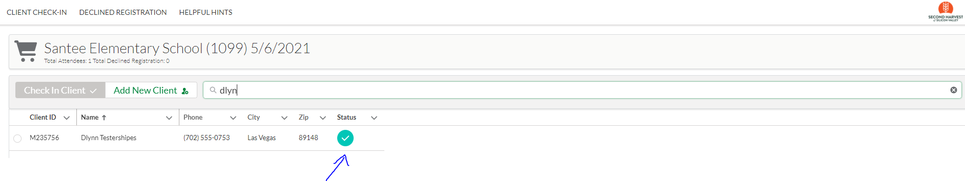

Scenario 2: Add client to this distribution. A client is new to this site but has been to another Second Harvest-run distribution.
- Click on the Add New Client button next to the search bar.

- You will see this search screen:
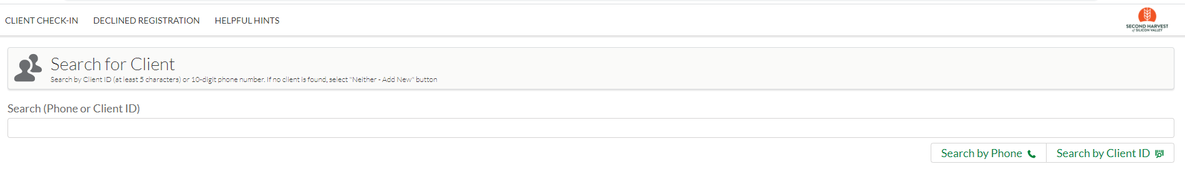
- Enter either the Client ID (including the M) or the client’s full ten-digit phone number (you don’t need any formatting). If you entered the Client ID, click on the “Search by Client ID” button below the search bar. If you entered the phone number, click on the “Search by Phone” button below the Search bar.

- If the client has gotten Free Groceries from a different site, they should appear on the results page. Select that client by clicking on the bubble to the left of their name.
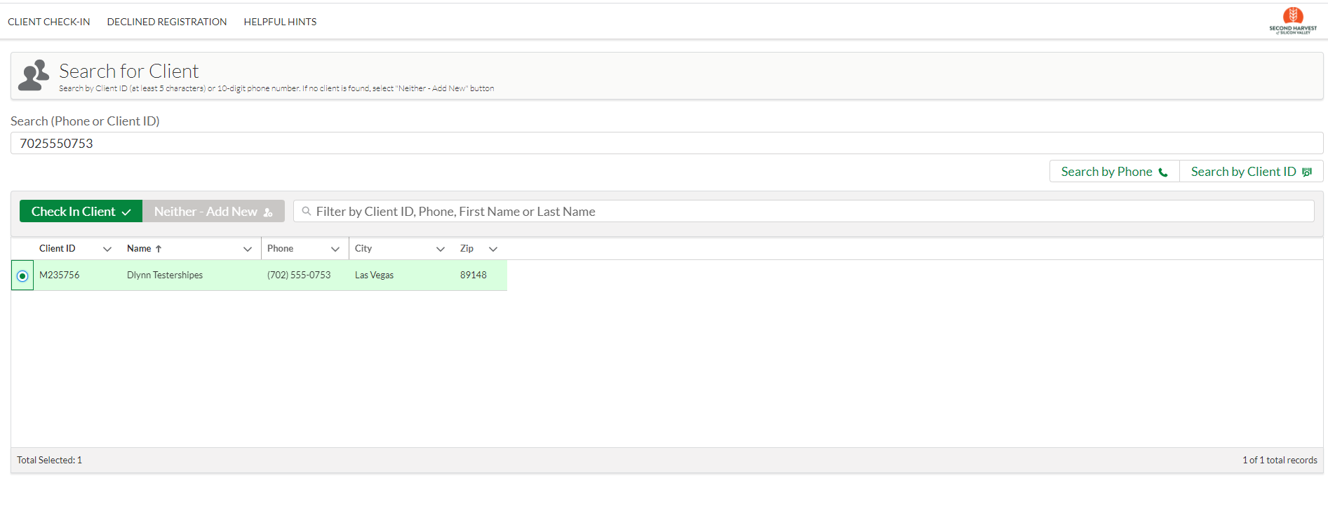
Then click on the green Check In Client ✅ button under the search bar. You will be taken to the Confirm Check-In screen. Make any updates to the client’s information in the Update Client Information, Add Notes box and click on the green “Received Food” button or the “Did not Receive Food” button.
To Cancel the check-in in process or if you have selected the current client in error, press the white Cancel button at the bottom of the screen. Cancelling will cancel attendance and return you to the original Check-in Screen.

**Please confirm any updates with the client before sending.

- Marking the client as “Received Food” or “Did not Receive Food” will result in the client being added to the attendance for the distribution. You will return to the original check-in screen.

- Once a client has been checked in, they cannot be selected again. A green bubble will appear to the right of their name to indicate that they’ve already been marked as attended.

Scenario 3: Register a new client
A client has never attended a Second Harvest-run distribution

- If a client says they have never gotten free groceries from any site, let them know you are going ask them a few questions to get them registered. They only need to provide the information they are comfortable sharing. It is not required to get food. Let them know we will be asking for the following and they only need to give what they are comfortable providing:
  - Name
  - Year they were born
  - Address
  - Cell phone number
  - Preferred language
  - Number of people in their household
  - Ethnicity
Assure them that their information will be stored in a secure database and will not be shared between anyone other than Second Harvest and the organizations where they get food.

If they say “ok”, proceed to #2.

If they say “no, it’s not ok” or are very skeptical/unsure, let them know this is fine. To register them, all we need is their name (or initials) and one of the following: birth year, zip code, cell phone number or how many in their household.

If they agree, ask them if it’s ok to search for them by phone number to make sure they aren’t already in the system.
    - If they are ok providing their phone number, proceed to #2.
    - If they don’t want to be searched by phone number, go to #3.
If they do not want to give any information, let them know it’s no problem, they will still get their groceries. Click the Declined Registration tab at the top of the screen. Go to “Scenario 4: Client Declines Registration” for more instruction.

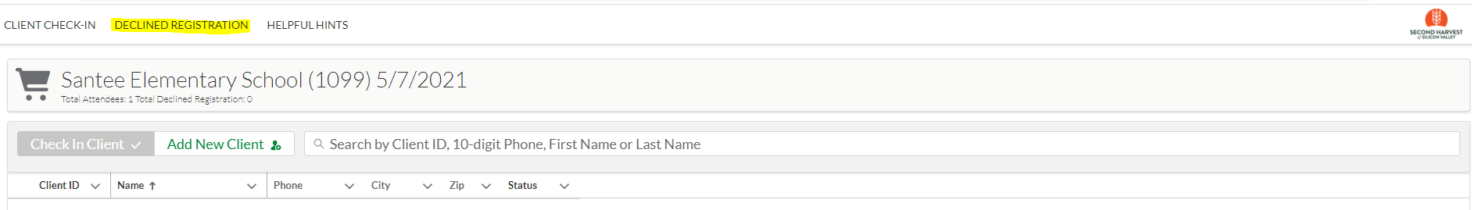

- Search for Client by Phone number. Enter the phone number and select “Search by Phone”. It is possible that they have already been entered into the system.
- You will see the following screen when no result is returned. If no result is returned, click on the green “Neither - Add New” button next to the search bar.
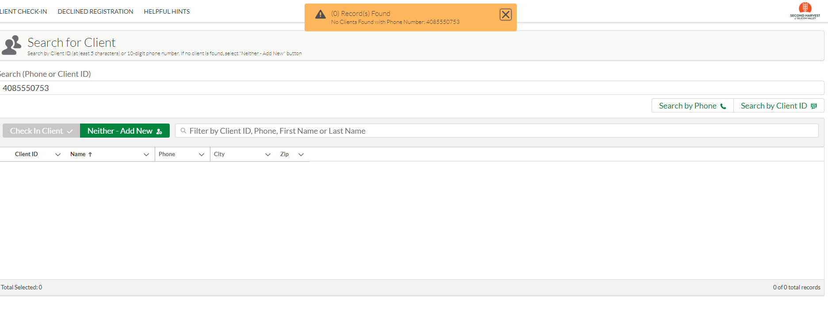

Once you click on the Neither-Add New button you will see the New Client registration page. The phone number you used for the search will automatically populate into the Phone box.
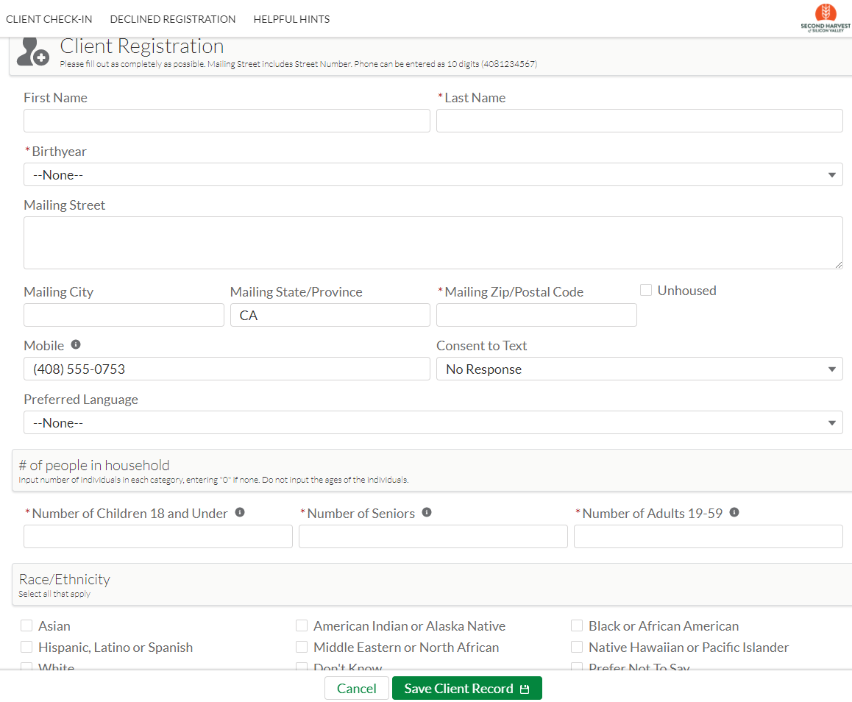

- Please fill in all client information as completely as possible, remembering that clients do not have to provide any information they are not comfortable sharing. In order to register a client, we need at least their name (or initials) and one other piece of information. We also require that you fill in that there is at least one person in their household. Please try to use proper capitalization.
Example:
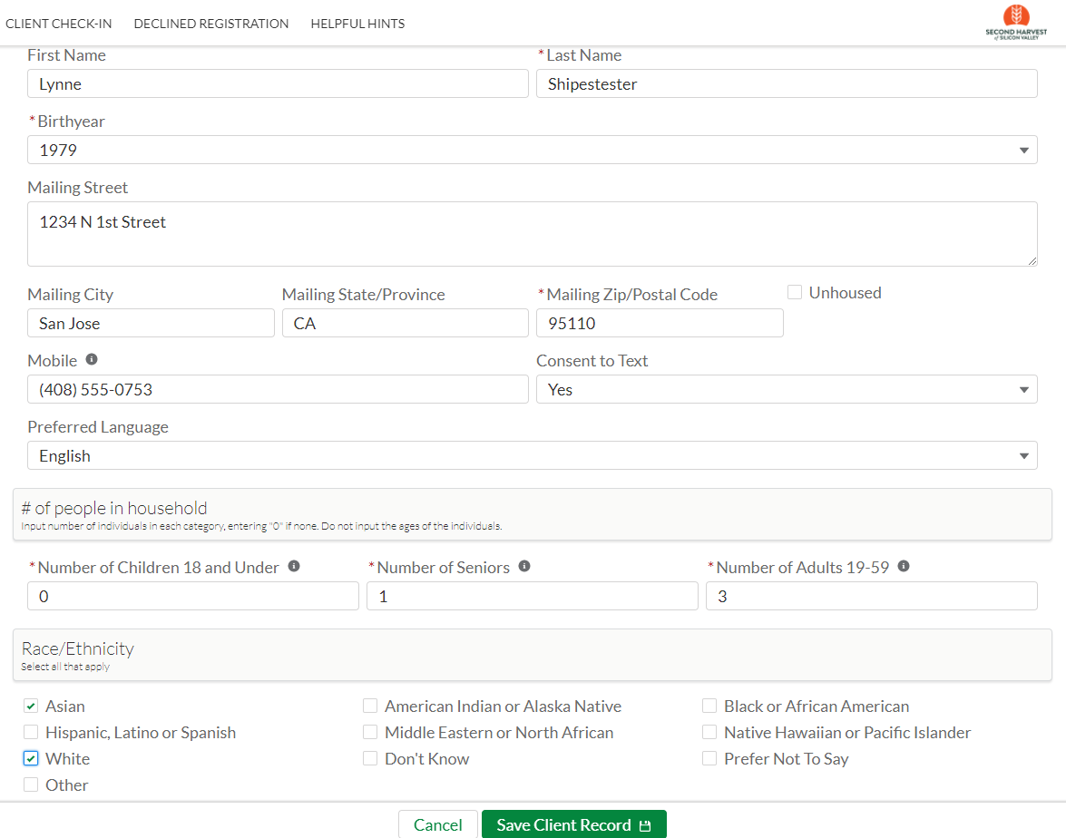

- Once you have filled in the client’s information and verified it with the client, click on the green “Save Client” button.

- You will be directed to the Confirm Client Check-in screen. Please WRITE DOWN THE CLIENT ID NUMBER FOR THE CLIENT on their Client card. Then select the green Received Food button and you will be directed back to the main client check-in screen.

If for any reason you do not wish to create the client record (the client found their Client ID card or decided they didn’t wish to continue) click on the white Cancel button. You will be returned to the main Client Check-in screen.

- Marking the client as “Received Food” or “Did not Receive Food” will result in the client being added to the attendance for the distribution. You will return to the original check-in screen.

- Once a client has been checked in, they cannot be selected again. A green bubble will appear to the right of their name to indicate that they’ve already been marked as attended.

Scenario 4: Client declines to register
- If a client decides they do not wish to share their information with Second Harvest, please select Declined Registration at the top of the screen. Choosing Declined Registration allows Second Harvest to maintain an accurate count of clients served while allowing a client to remain anonymous.
Choosing Declined Registration will bring you to the “Check-in Client who Declines Registration page”.
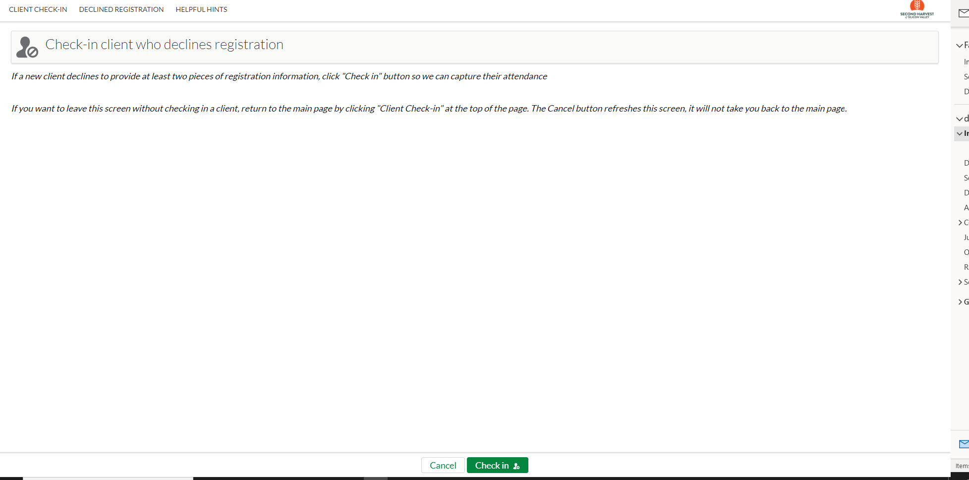
- Select the green “Check in button” at the bottom of the screen to record the client’s attendance without providing their information.

- Confirm that you wish to proceed after clicking on the green Check in button.
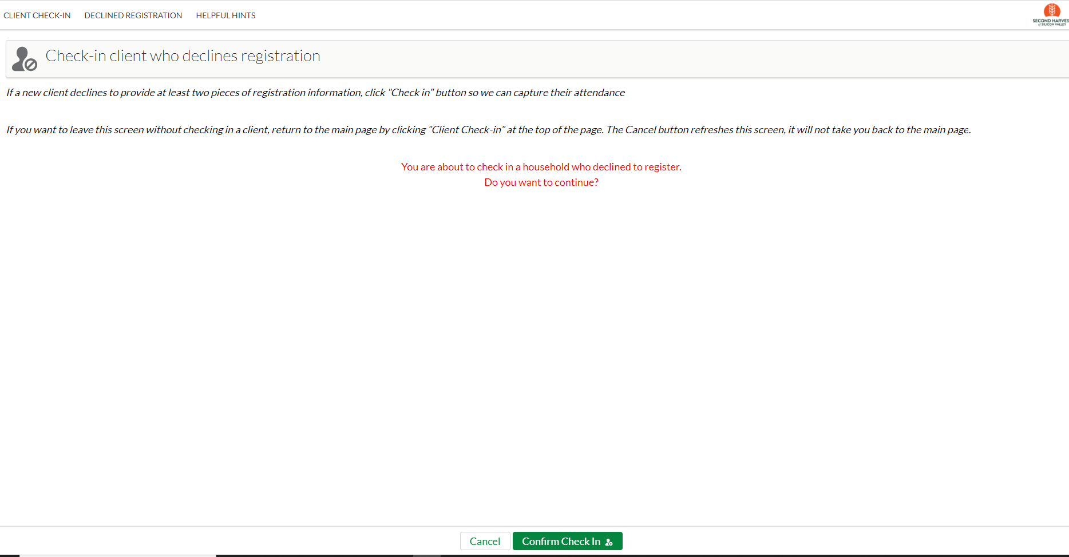
To continue, click on the green Confirm Check in button. You will then be routed back to the main client Check-in page.
If you do not want to proceed with checking in a client as Declined Registration, please select Client Check in at the top of the page to be returned to the main Client Check in page.

