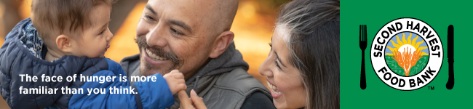

Subject: Hunger Takes a Seat at the Holiday Table

Dear [Name],

The holidays can be a magical time for some, filled with festive gatherings, family traditions and an abundance of food. But for many, it’s also a painful time because budgets are already tight and nutritious food is scarce. Even here in wealthy Silicon Valley, hunger will take a seat at too many tables this holiday season.

Second Harvest is serving more people than ever before – an average of 260,000 kids, families and seniors every month. That’s because the cost of housing has skyrocketed with the booming economy, while wages have remained relatively flat for many. It’s called the Silicon Valley hunger paradox – as the economy grows, so does the number of people who need food.

The good news is we have the power to fight back against hunger and create a real difference by making [Fundraiser name]’s Fundraiser a big success. With your support, every dollar donated will create two nutritious meals for those in need and help to ensure that we all have the food we need to fully engage in our lives, no matter who we are or what table we sit at this holiday season.

Thank you for your support!

Sincerely,

[Name]
[Name of Organization or team]

