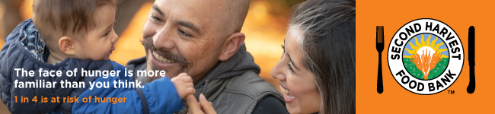

Subject: There is Still Time to Help!

Dear [Name],
The holidays are a difficult time for many hardworking families who can’t afford to pay rent and buy the nutritious food their kids need to thrive. It’s sad to think there are kids in Silicon Valley who will go to bed hungry this holiday season because their parents don’t earn enough to buy food, but you can help make a difference.

With your support we can ensure anyone who needs a healthy meal can get one. Donate here [hyperlink your custom URL] before [insert end date here] to help those in need this holiday season. You can also create your own team as part of our fundraiser to share with your family and friends. Remember, every dollar donated creates two nutritious meals for families struggling to put food on the table. Our neighbors are counting on us. We can do this!
For those who have already donated, our humblest thanks. Your generosity is helping make the holidays a little brighter for so many families, children, and seniors.

Sincerely,
[Name]
[Name of Organization or team]

