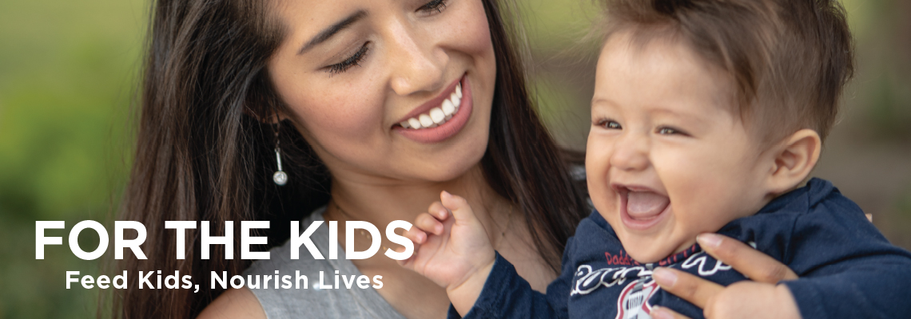

Subject: You Can Help Fight Hunger

Dear [Name],

Nutritious food is the foundation for a healthy, productive life. Hunger hurts because it keeps us from fully engaging in our lives and fulfilling our dreams.

Second Harvest is serving more people than ever before – an average of 260,000 kids, families and seniors every month. That’s because the cost of housing has skyrocketed with the booming economy, while wages have remained relatively flat for many. It’s what we call the Silicon Valley hunger paradox – as the economy grows, so does the number of people who need food.

The good news is we have the power to fight back against hunger and create a real difference by making [Fundraiser name]’s Fundraiser a big success. With your support, every dollar donated will create two nutritious meals for those in need and help to ensure that we all have the food we need to fully engage in our lives.

Thank you for your support!

Sincerely,

[Name]
[Name of Organization or team]

