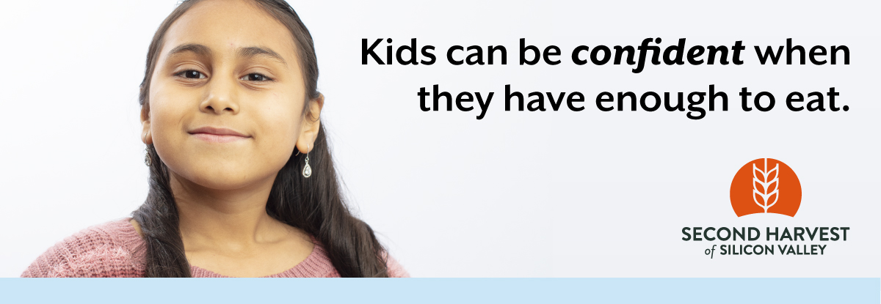

Subject: There Is Still Time to Help!

Dear [Name],

A record number of kids, families and seniors rely on Second Harvest of Silicon Valley for food every month, and the number is growing. It’s hard to imagine the pain of not being able to feed your family, or going to school on an empty stomach. But the reality is more than 1 in 4 people is at risk of hunger in Silicon Valley.

With your support, we can ensure anyone who needs a healthy meal can get one. Donate here [hyperlink your custom URL] before [insert end date here] to give hope those in need. You can also create your own team as part of our virtual food drive to share with your family and friends. Remember, every dollar donated helps provide two nutritious meals for families struggling to put food on the table. Our neighbors are counting on us. We can do this!

For those who have already donated, our humblest thanks. Your generosity is helping make the future a little brighter for so many families, children, and seniors.

Sincerely,

[Name]
[Name of organization or team]

