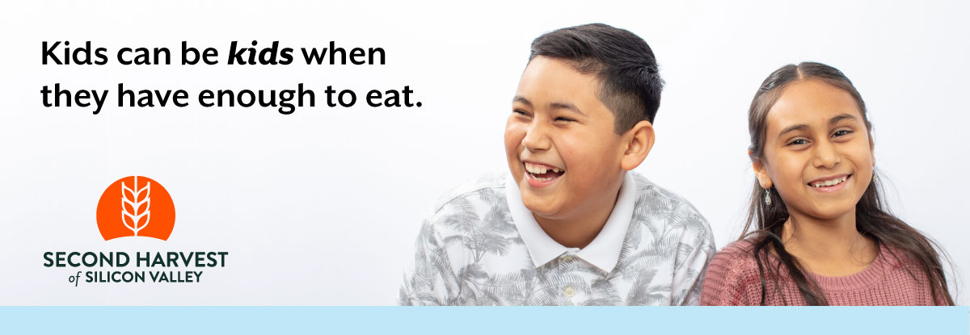

Subject: How We Can Help in Uncertain Times

Hi [Name],

As our community deals with the COVID-19 public health crisis, neighbors experiencing or on the brink of poverty are disproportionately impacted.

Second Harvest of Silicon Valley remains committed to providing nutritious food to anyone who needs it. [Virtual food drive name] does too.

Join me in helping Second Harvest respond to the increased need and continue providing food all throughout Santa Clara and San Mateo counties. If we hit our goal of [Fundraising goal] we’ll provide [Fundraising goal x 2] meals for local families who need them now, more than ever.

Donate securely at: [Your custom URL]

It’s hard to know how to help in these uncertain times. I choose to help Second Harvest because I’m confident knowing that 95% of all contributions go toward programs that feed people.

Our community needs us!

Thank you,

[Name]
[Name of organization or team]

