Header Image:

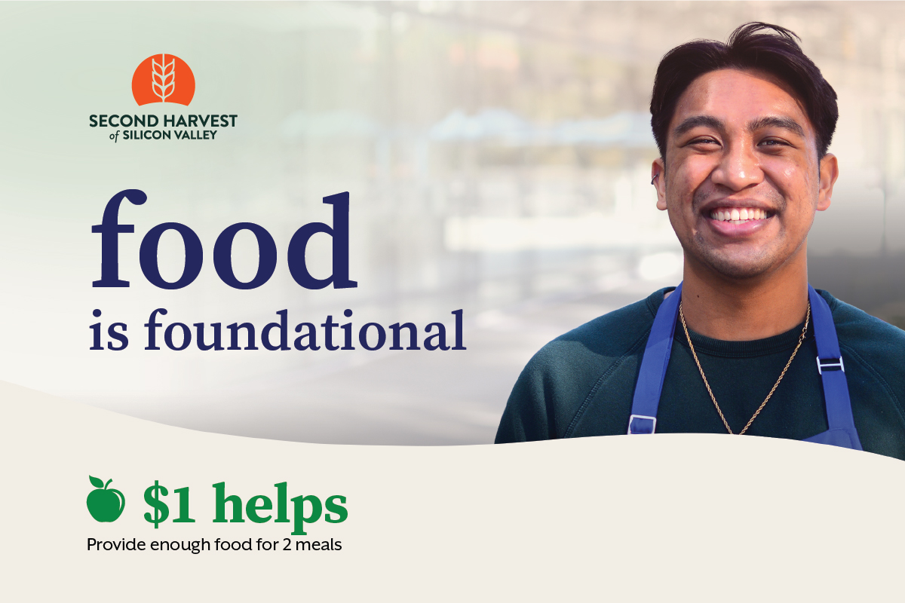

Subject: Help provide nutritious food to our neighbors

Hi [Name],

Since the start of the pandemic, the need for food has skyrocketed. Second Harvest of Silicon Valley is now serving 450,000 people on average every month, an 80% increase over pre-pandemic levels.

Community support has been vital to Second Harvest’s ability to meet the dramatic increase in need. Helping those in our community is what [Virtual food drive name] is all about.

Your gift to Second Harvest helps provide hope and security to families across Silicon Valley who are still recovering from the financial devastation caused by the pandemic. A gift of $1 helps provide enough food for 2 meals.

Will you join [me/us] in helping provide nutritious food to our community?

You can donate at [Your custom URL].

Thank you,

[Name]
[Name of organization or team]

