Header: 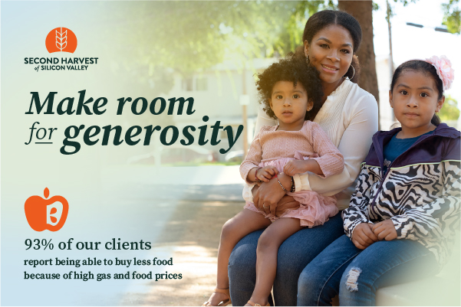

Subject: Together we did something incredible

Hi [Name],

Thank you for making a gift to [my/our] drive benefiting Second Harvest of Silicon Valley. Free groceries from Second Harvest ensure that no one in our community has to choose between paying rent and putting food on the table.

Your generosity raised $ [Total dollars raised], helping to provide enough food for an amazing [Total dollars raised x 2] meals for families, kids and seniors.

Thank you for helping build a hunger-free community.

Sincerely,

[Name]
[Name of organization or team]

