Header:

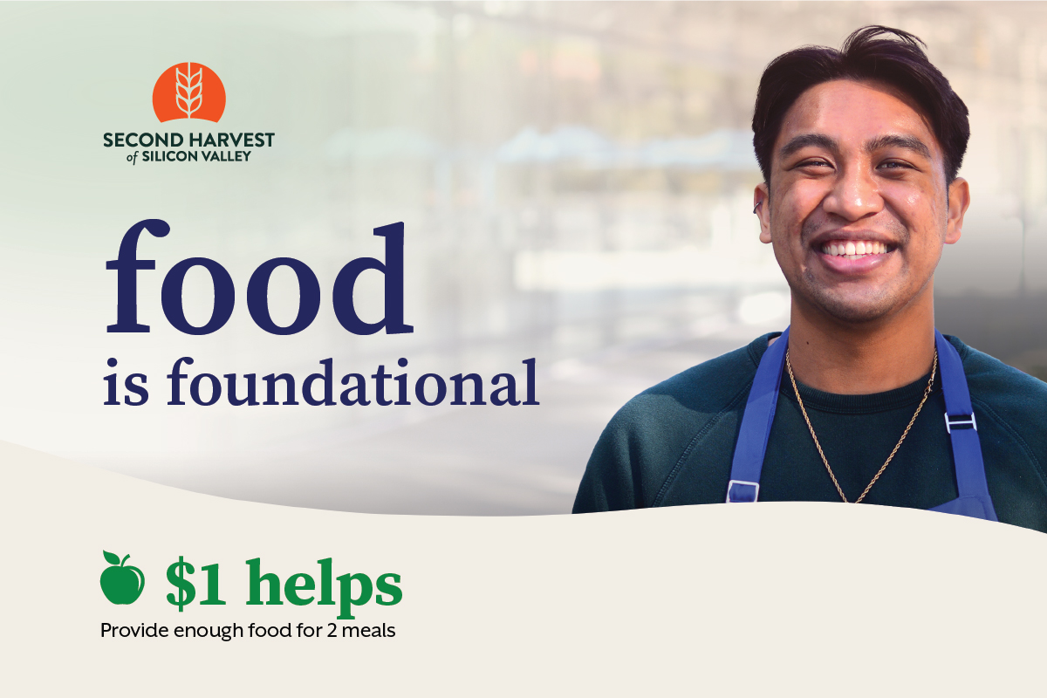

Subject: We are so close!

Hi [Name],

With your help, we can make a difference in our community. Your gift to Second Harvest will help ensure 450,000 neighbors across Silicon Valley have access to the nutritious food they need each month.

If you haven’t made a gift to our drive yet, there’s still time! You can help us reach our goal by donating here [hyperlink your custom URL] before [insert end date here]. $1 helps provide enough food for 2 meals.

For those who have already made a gift, thank you. Please share on your social media pages and invite your family and friends to donate!

Together we can ensure that anyone who needs a healthy meal can get one.

Sincerely,

[Name]
[Name of organization or team]

